REPORT NUMBER: 10
Clients.Client Name
Clients.Address, Clients.City, Clients.Province
Projects.Project Name
Inspections:
Report Number
Report Date
Report Time
Inspection Company
Inspector Name
Roofing Contractor
Foreman
Crew Size
Weather

DATE: June 23 2009
TIME: 11:00 AM

ROOF AREA(S): 3.0 – 22,451 sq. ft.

INSPECTION AUTHORITY: Pro-Spec Roof Consultants & Associates
Alistair Wilson

ROOFING CONTRACTOR: Industrial Roofing
FOREMAN: Adeline
CREWSIZE: 7 men

WEATHER: Sunny , 25Deg. C., 0% Chance of precipitation.
InspectionActivities:
Name Today Cumulative

CURRENT OPERATIONS:

Activity | Today | Cumulative to Date
Gravel removal, site preparation

COMMENTS: The contractor has removed and replaced thirty squares of existing roof system. There was no evidence of rusted or damaged deck in the area removed today. During the installation of the insulation fasteners an electrical conduit was damaged. The owners were notified and an electrician has called to effect repairs. The conduit was located in unit 10 . T

The fasteners were checked for torque and observed to be properly secured. The contractor has installed the coverboard flat and free of voids. The application of the roofing felts was observed and the felts were applied flat and free of wrinkles. The contractor will gravel off this afternoon. The night tie in was being prepared during the inspection period.
Inspections.Comments

Following are photographs from today’s site visit.

The crew has removed and replaced thirty squares of roof today.

The contractor is installing insulation fasteners. An electrical conduit was damaged during this installation causing a power outage in Unit 10

The contractor is installing the coverboard into a full mopping of hot asphalt

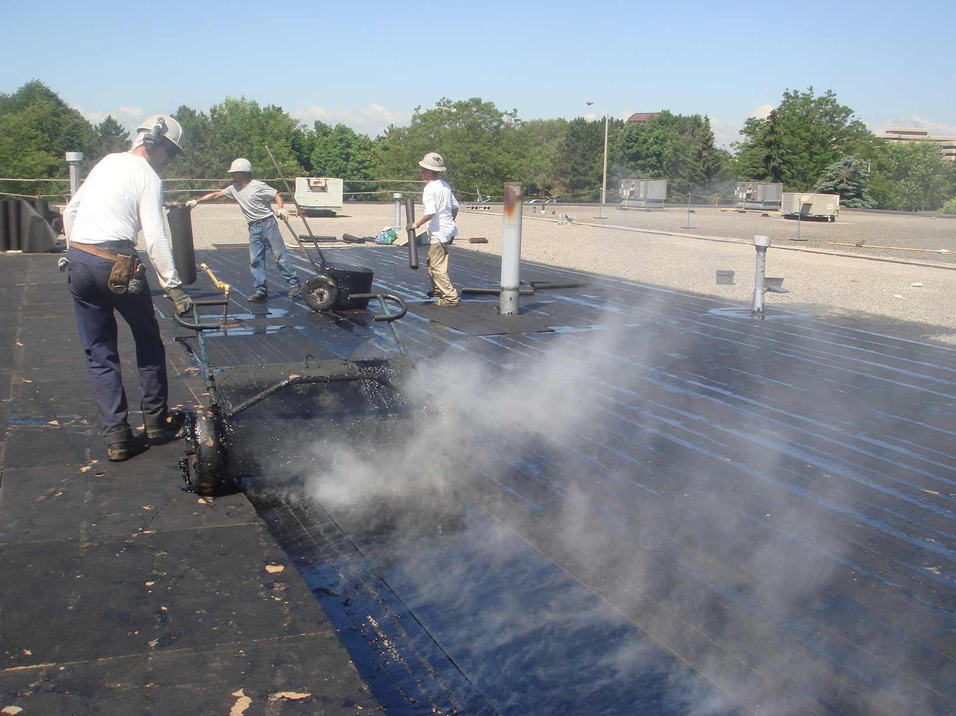

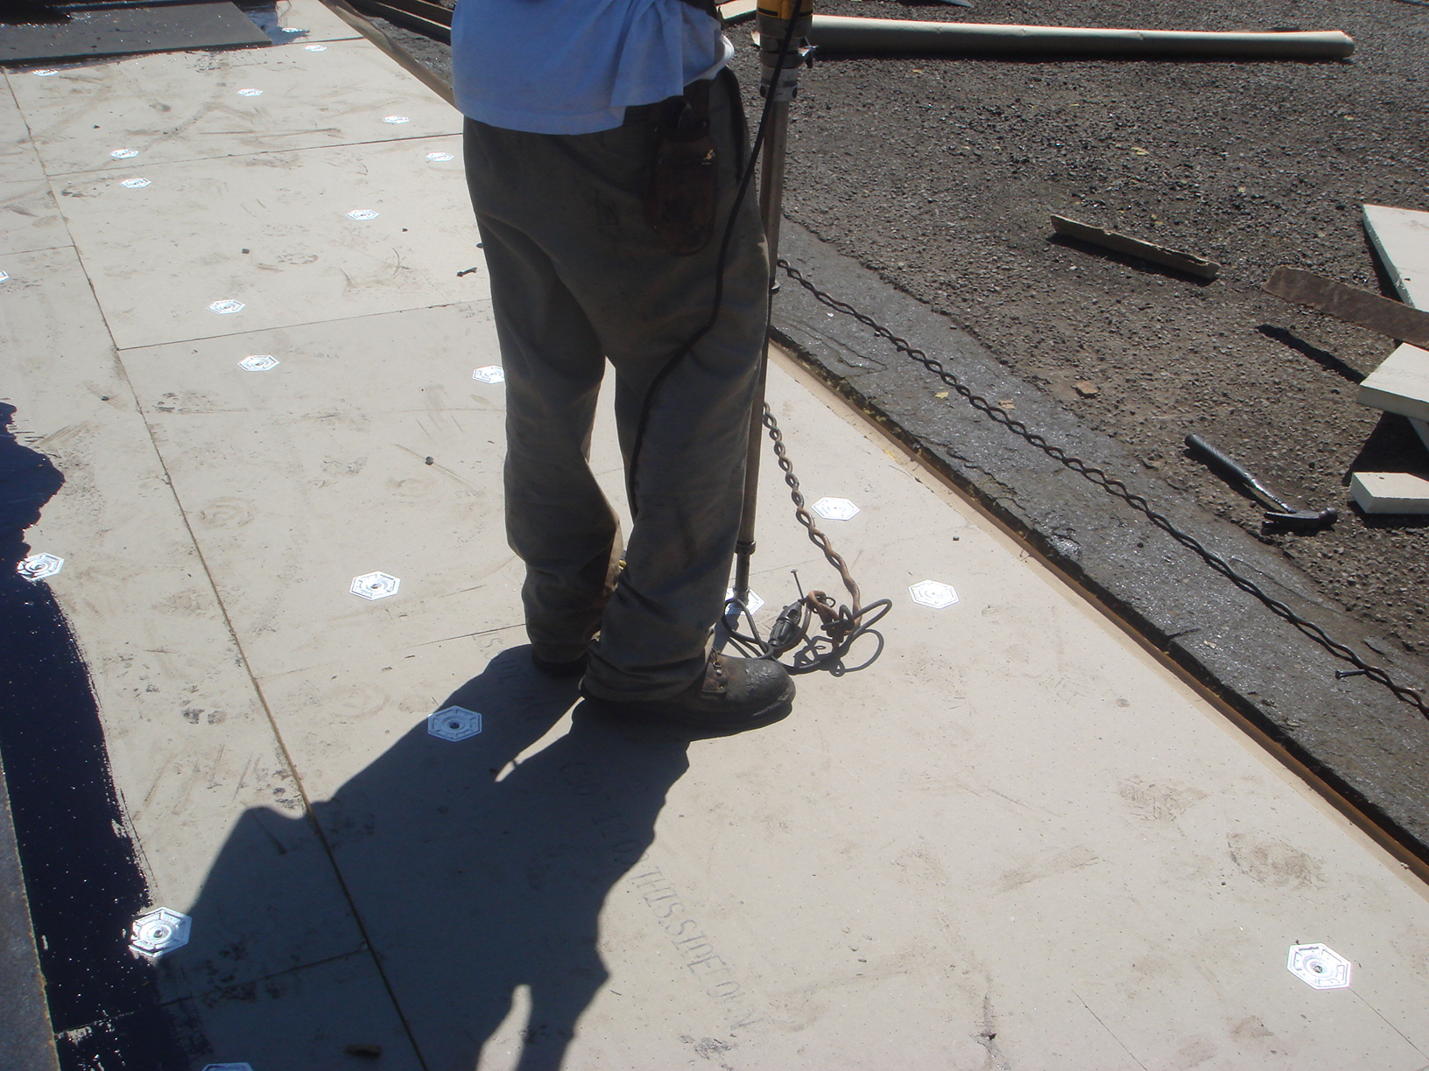

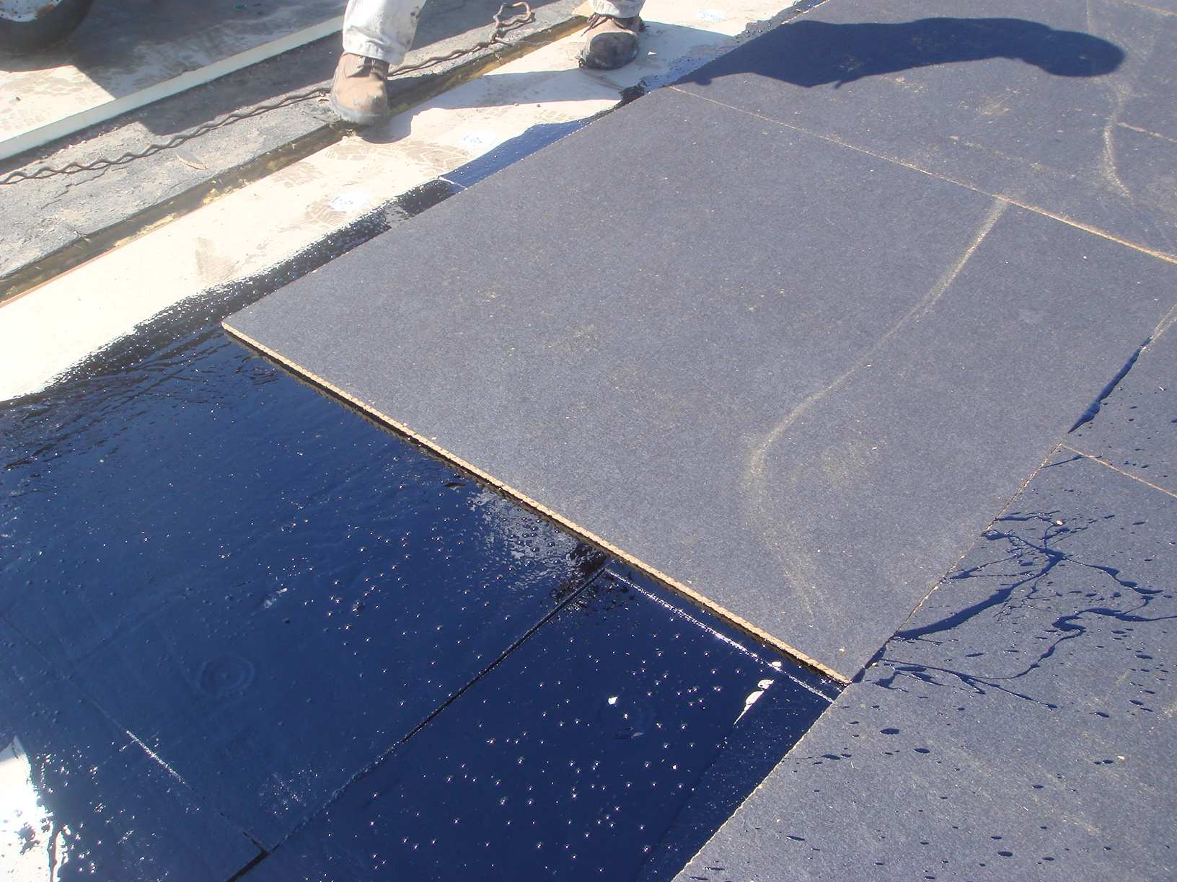

InspectionPhotos.Photo

InspectionPhoto.Annotation

